Difference-in-Difference Models

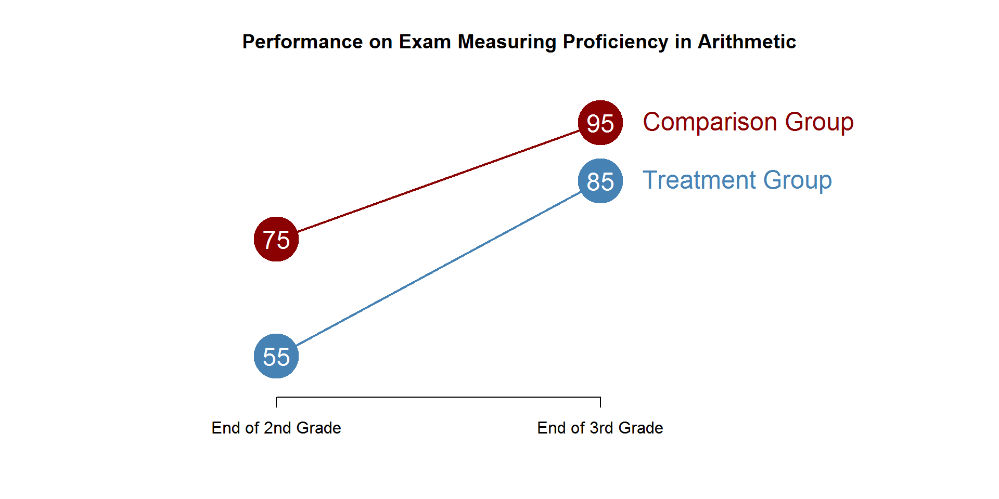

Using the diagram above calculate the following:
- Trend (C2 – C1):
- The Counterfactual: T1 + Trend
- Total Treatment Gains (T2 – T1):

- Program Effects: Total Gains – Trend

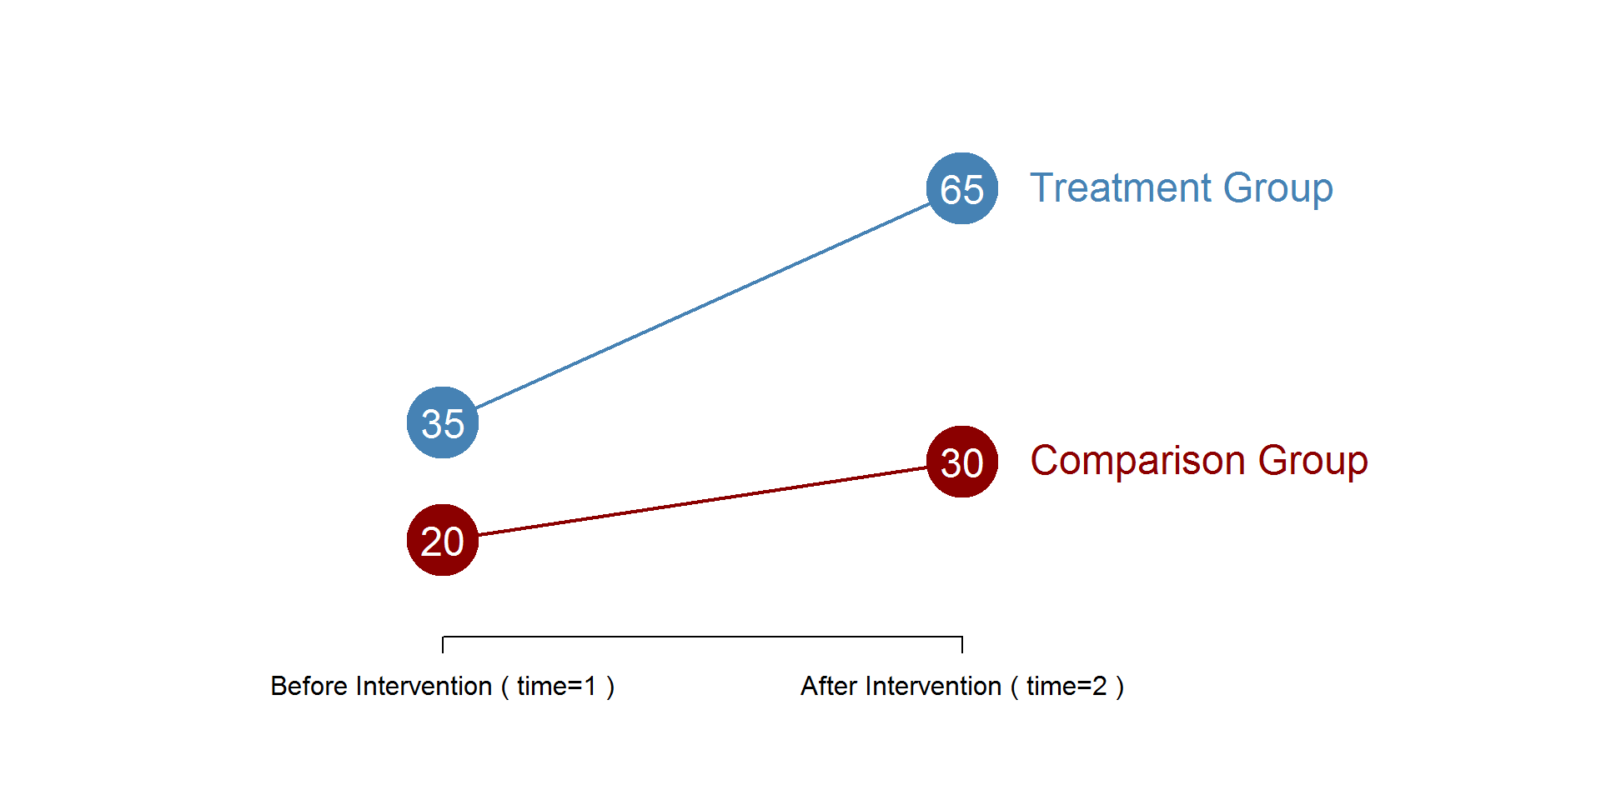

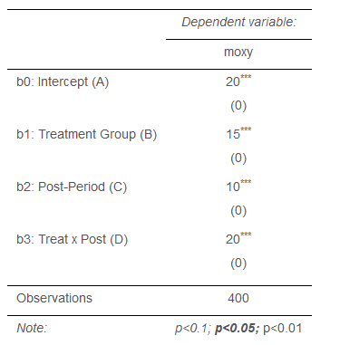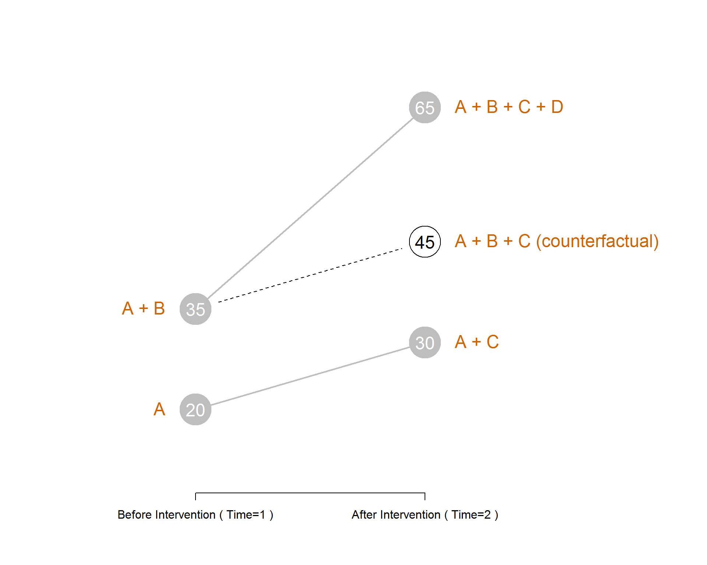

Use the results from the difference-in-difference regression table above to answer the following:
- What is the group mean for C1?
- What is the group mean for T1?
- What is the group mean for C2?
- What is the counterfactual?
- Does this program have an impact, and if so how much (effect size)?
Regressions with Interaction Effects

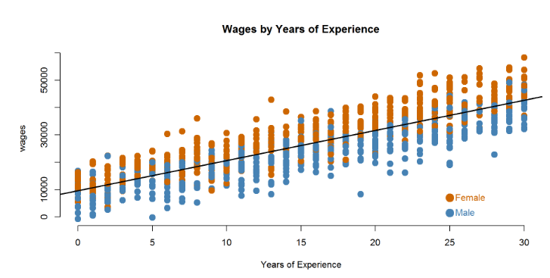

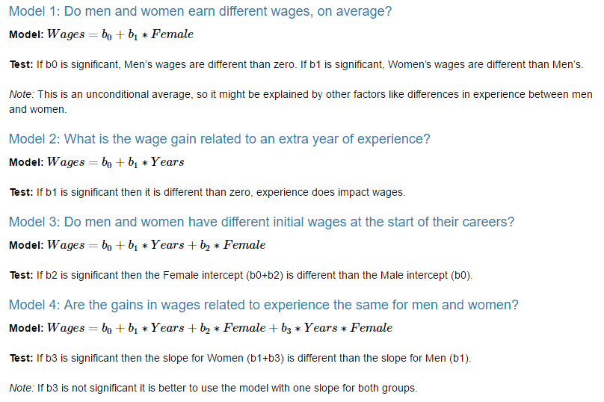
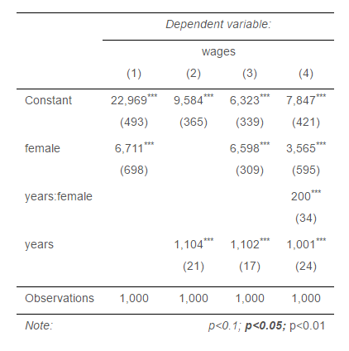

Use Model 4 to answer the following questions:

- How much do men earn in their first job (zero years of experience)?
- How much do women earn in their first job?
- What is the average raise men receive each year?
- Do men and women receive different raises? How do we know?
- What is the average raise women receive each year?

Varying Effects by Groups: Corn Hybrids

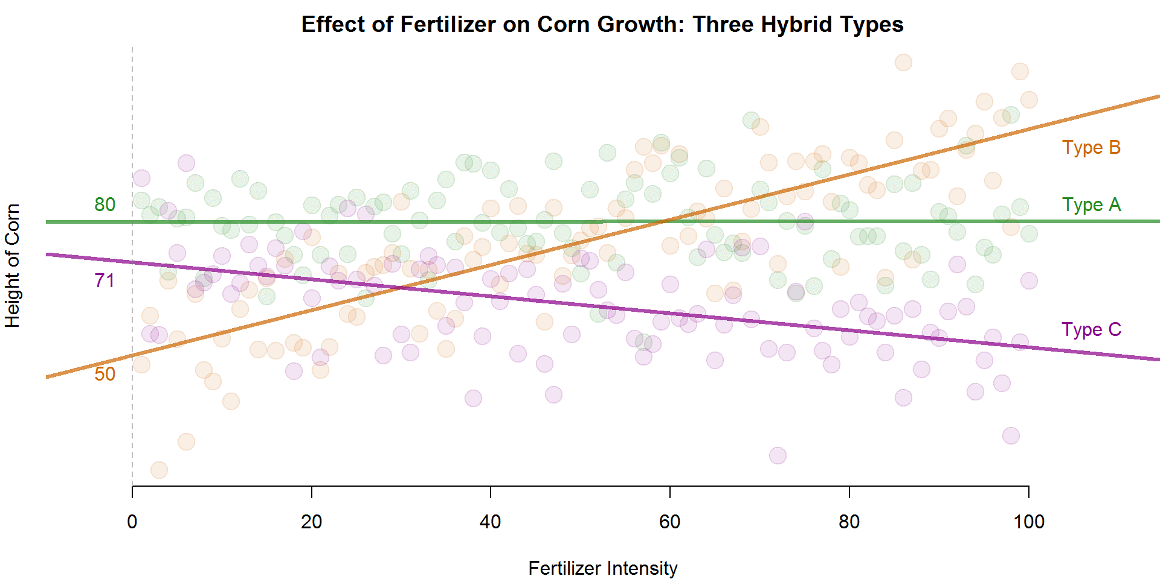

Use the table below to answer the following questions:
- What is the average height of Hybrid A corn?

- What is the average height of Hybrid A without fertilizer?

- For each unit of fertilizer added, how much will Hybrid A grow?

- Which hybrid grows best at low levels of fertilizer? High levels?

